Deliverable: Research and Requirements

Group Name: TheDevArchitects
Instructor: Gursharan Tatla
Course: INFO34049 Capstone Prototype

Team members

Full Names | Student ID | Role
Abdulrahman Chalya | 991669439 | Team Lead
Ajit Singh Brar | 991538106 | Full-Stack Developer
Thanh Tung Le | 991751027 | Front-end Developer
Khang Bui | 991698043 | Back-end Developer

Table of Contents

Introduction 3
Research Summary 3
Project Risks 5
Context Diagram 6
System Architecture Diagram 7
Wireframe 8
Website Wire Frame 8
Mobile Wire Frame: 12
Design Requirements/Constraints 15
References 17

Introduction

GetawayHub is an all in one trip planner that will plan a trip start to finish, and with just a few words. When you input your budget, vacation days and interests, GetawayHub will plan accordingly with up to date and live flight data, weather data and any concerns a traveller might have. It will find restaurants, activities, sights, and views based on interest. It will consider replans and specific interests. And as you experience your amazing vacation, GetawayHub will keep you safe and updated on anything that could disturb your adventure.

Research Summary
Market size & momentum
International tourism has recovered and surpassed pre pandemic levels, signalling sustained demand (UN Tourism 2025; AP News 2025). At the same time, the online booking keeps gaining market share and is expected to account for 65% of bookings by 2026 (Phocuswright 2025; TravelAge West 2024). A summer travel survey shows demand remains healthy while travellers seek value and a simpler decision journey, creating an opportunity for AI tools that compress research, comparison, and booking into a single flow (Deloitte 2025a; Deloitte 2025b).

Competitive landscape
Incumbents have added AI features (e.g., Booking.com’s AI Trip Planner; Tripadvisor’s AI Trip Builder), but these tools are still poor at fusing live operations (flight/traffic/weather/advisories) into the itinerary itself (Booking.com 2023; Booking.com 2024; Tripadvisor 2023; Tripadvisor 2024). GetawayHub differentiates by integrating that feature so plans stay feasible and up to date in real time. Academic and industry literature likewise points to tourism applications using AI but emphasizes the need for reliable external tools/data to handle constraints and dynamic context (de la Rosa et al. 2024; Shao et al. 2025). This supports GetawayHub’s extensive AI + API architecture.

Feasibility: data & real-time integrations
- Flights: Production-grade status/operations data via Amadeus, Cirium, Aviationstack, FlightLabs (Amadeus n.d.; Cirium n.d.; Aviationstack n.d.; FlightLabs n.d.).

- Traffic: TomTom Traffic Incidents/Flow for congestion and incident alerts (TomTom Developer 2024).
- Weather & alerts: OpenWeather “One Call 3.0” and Alerts for current, hourly, and daily forecasts plus governmental alerts (OpenWeather n.d.-a; OpenWeather n.d.-b).
- Safety advisories: U.S. State Dept and Government of Canada advisories via RSS/API datasets to trigger itinerary warnings and reroutes (U.S. Department of State n.d.; Government of Canada n.d.).

Privacy & security (regulatory alignment)
GetawayHub will collect only what’s necessary for itinerary creation and live updates. We will also provide clear consent, data-export, and deletion flows.

Project Risks

1. Technical Risks
- User Data Exposure (SQL Injection): The app also stores sensitive user information like names, bookings, and payments from which hackers can steal
- External API Dependence (Missing API Detail): Calling external API services such as Weather, Traffic or Hotel API could lead to problems if the API are compromised or giving you incorrect data (IBM, 2022).
- AI Data Leakage (Layer 7 Exploits): The AI system could accidentally reflect travel behavior of a user if the data are not secured.

2. Resource Risks
- Limited Security Expertise: The project will neither use adequate numbers of experts on security nor refrain from making mistakes.
- Server Overload (Not Scalable): Real-time data such as flight schedules or traffic advice may overload servers, and a poorly conceived configuration may spill information (Magerramov, 2025).

3. Scope Risks
- Overloaded Features: Including too much at once (AI planning, booking, weather, flights) increases the odds of missing out on details regarding security (Brenner, 2024).
- Weak Authentication (Not Authorized): Login and authentication could be streamlined to expedite the process, yet that leaves an attacker with an easy target.

4. Schedule Risks
- Delayed Security Testing (Late Review): If proper security checks are postponed until the end, fixing issues may cause delays.
- Regulatory Challenges (Compliance Pressure): Privacy and data laws may slow down the project if not accounted for early.

5. Competitive Risks
- Loss of Trust: A security problem could make users not trust the app, hurting its reputation.
- Competitor Advantage: Others will release sooner, and should there ever be a security problem at GetawayHub, competitors win.

Context Diagram

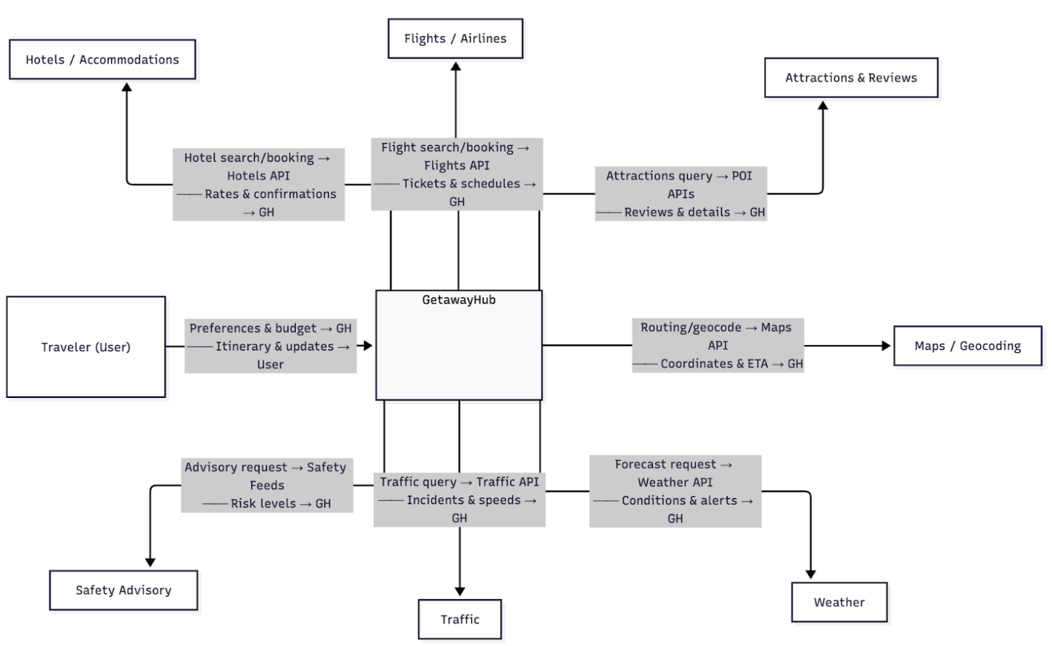

System Architecture Diagram

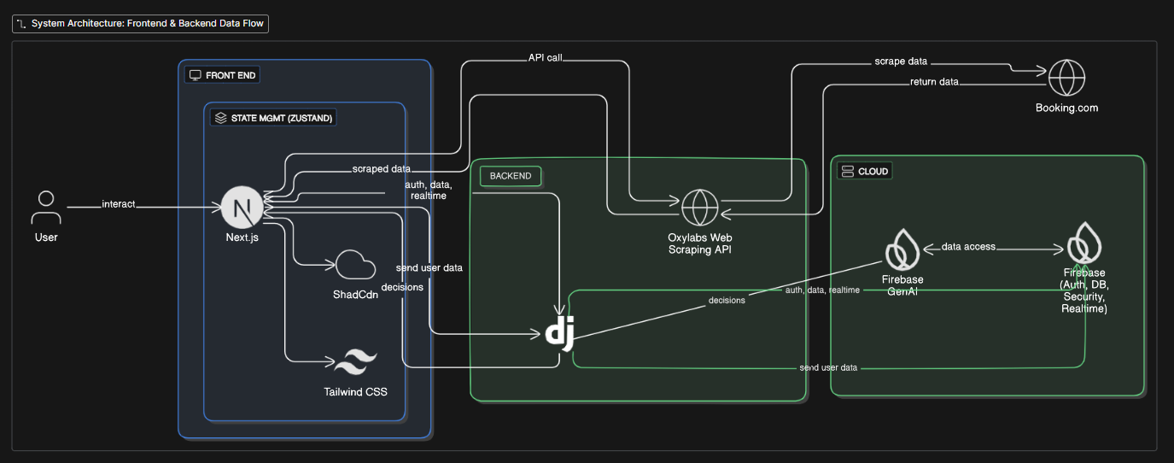

Front-End
- Next.js
- ShadCdn
- Tailwind CSS
- Zustand

Back-End
- Django (Rest API)
- Oxylabs Web Scraping API

Cloud Service
- Google Firebase
  - Database
    - Cloud Firestore
  - Authentication
  - Firebase Generative AI for making decisions regarding trip-planning

Wireframe

Website Wire Frame
Overview
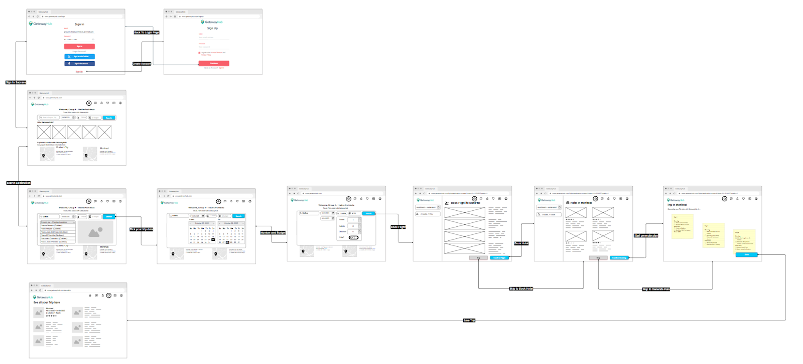
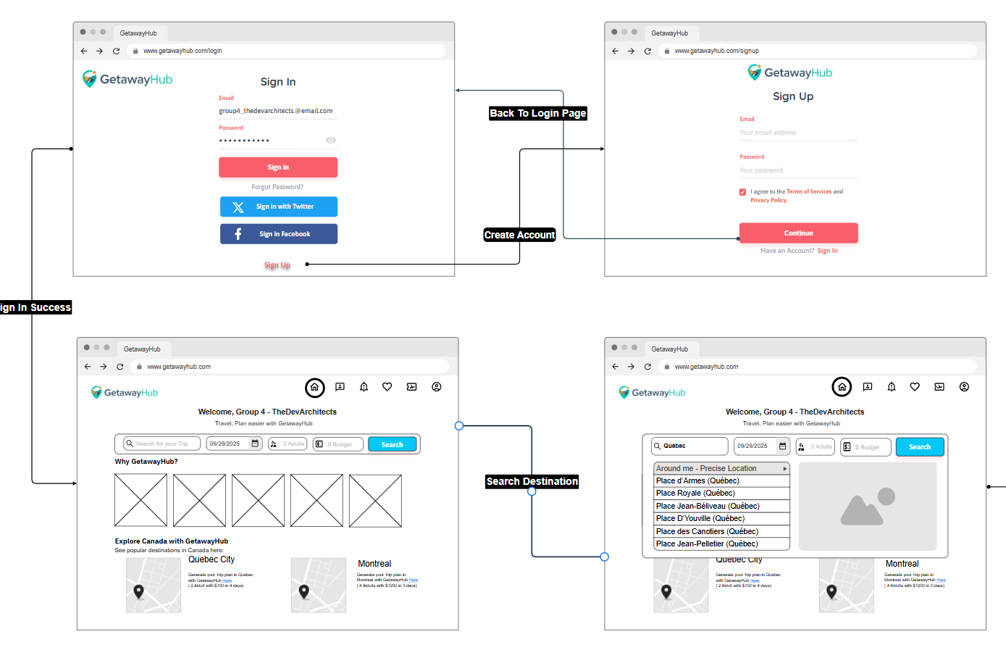
Login / Sign Up
- If you have an account → enter email + password → Sign In.
- If not → click Sign Up → create account → then continue.
Home Page
- After signing in, user lands on the dashboard.
- Shows welcome message, search bar, and popular destinations.
Search Destination
- Type a place in the search bar (ex: Quebec).
- Suggestions appear → pick one → click Search.

View Results
- Destination details and options appear (ex: Quebec City, Montreal).
- Users can explore trips.

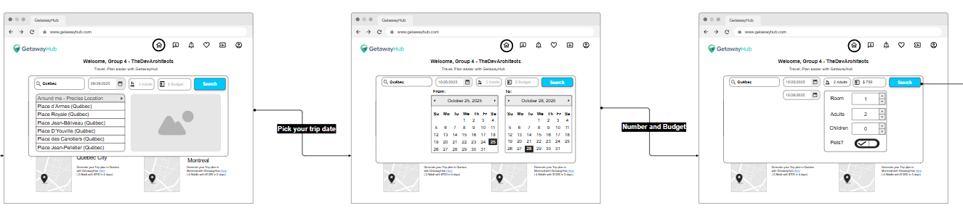

Pick Trip Date
- After choosing destinations, user selects travel dates from the calendar.
Set Travelers & Budget
- Enter number of adults, children, and budget.
- Press Search to confirm.

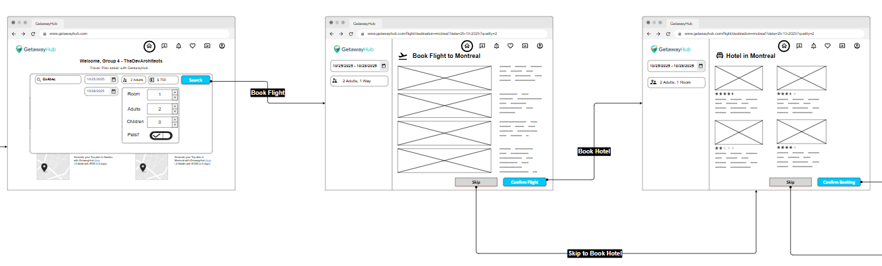

Book Flight
- User is shown available flights (example: Montreal).
- Choose a flight and click Confirm Flight.
- Or click Skip if user doesn’t want to book flights.

Book Hotel
- Next, user sees hotel options for the chosen destination.
- Pick a hotel and click Confirm Booking.
- Or click Skip to move on without booking a hotel.

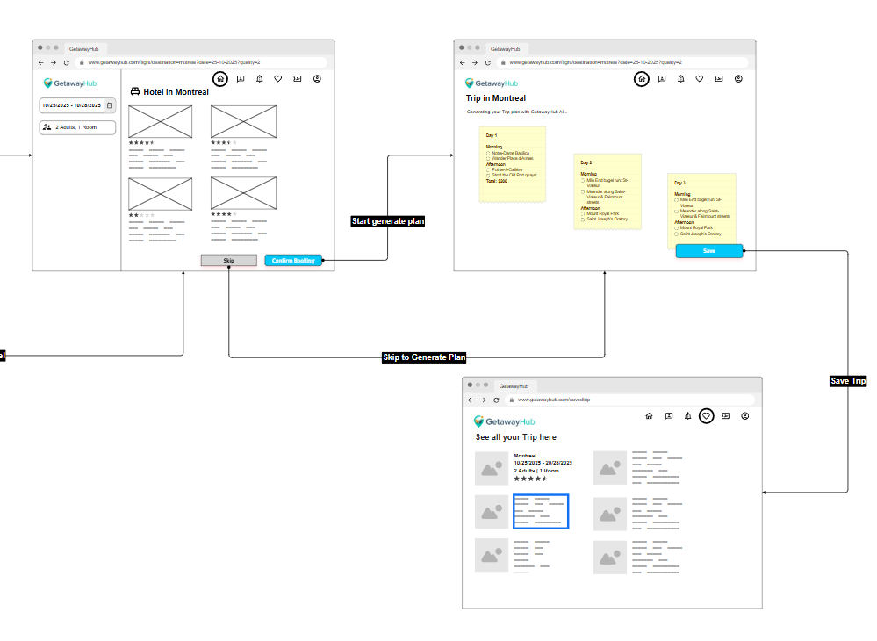
- After booking (or skipping) hotels, the system can create a Trip Itinerary.
- Example: Day 1, Day 2, Day 3 activities with morning/afternoon suggestions.
- User can review and adjust plan.
Save Trip
- Click Save to store the generated trip plan.
- Trip is saved under “See all your Trips” page, where user can view details (flights, hotels, activities).

Mobile Wire Frame:
Overview
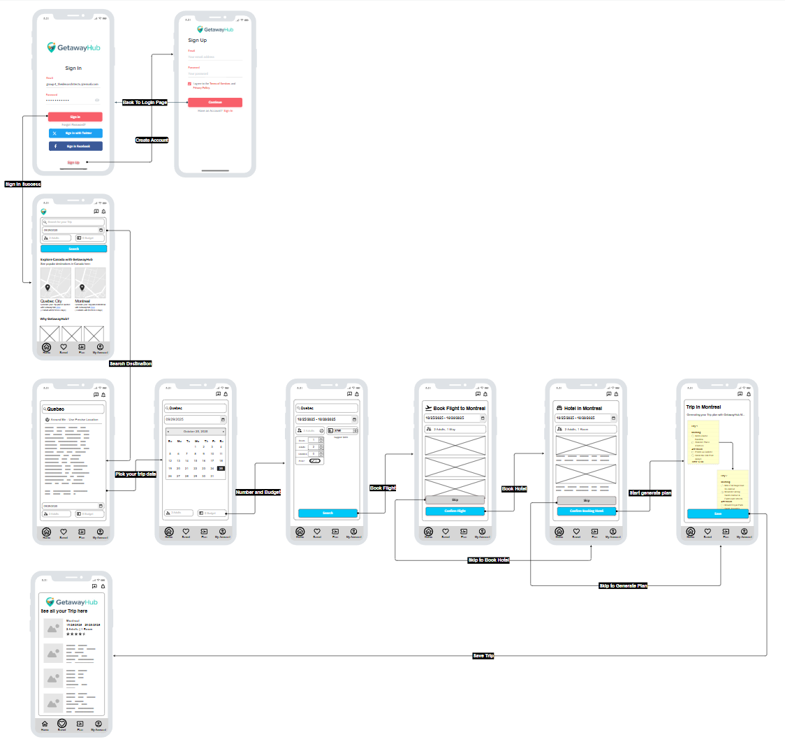

Workflow
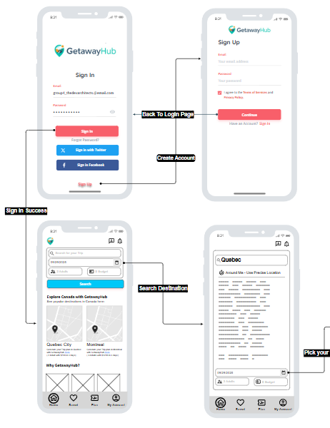

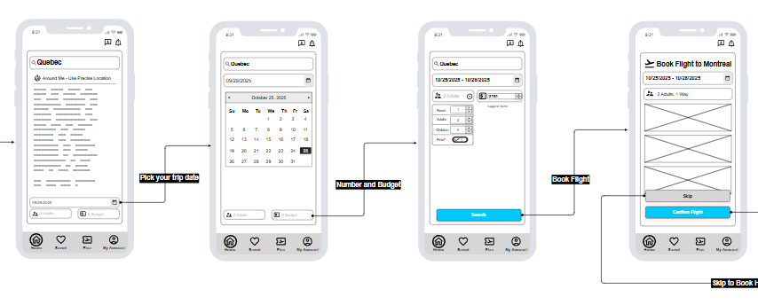

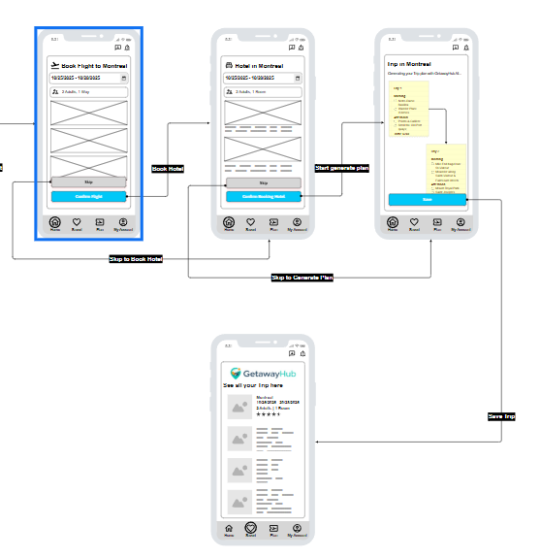

Design Requirements/Constraints

- Scope and Feature
- Able to search across the web for flights, stays and activities with real time pricing and availability
- Multi-day planner with editable schedule and map view
- Notification by email or push notification.
- Secure booking, payment and refund.
- User account with basic profiles, preferences and user can access their saved trips.
- Admin console for support or override if thing went wrong.

- Algorithm
- Feedback loop: click, saves, booking, cancellation.
- Performance Target
- Throughput: Can handle 500 requests per second.
- Latency: Should be able to read endpoint <300 ms from cache.
- Uptime
- Should be able to achieve 99% uptime monthly for login, search, booking.
- Scalability
- Stateless application with horizontal scaling.
- Rate limit traffic based on user and IP.
- Security Requirements
- Apply two authentication methods for user login.
- Payment: partner gateway tokenization.
- Required Interface
- Vendor API: At least 1 flight provider such as Air Canada and 1 stays provider.
- Map: Able to provide routing information.
- Payment: Use stripe for payment and refund.
- Messaging: Email and push notifications.
- Currency and tax: Should be able to calculate the exchange rate and tax when required.

- Supported System
- Web Browser: Chromium based web browsers such as Brave or Google Chrome and other web browsers Firefox, Microsoft Edge.
- Mobile Browser: Application.

References

- UN Tourism (UNWTO). 2025. “World Tourism Barometer and Statistical Annex, January 2025.” https://www.e-unwto.org/doi/abs/10.18111/wtobarometereng.2025.23.1.1
- Associated Press. 2025. “Spain Sets a New Record with 94 Million International Tourists.” January 15. https://apnews.com/article/spain-tourism-record-housing-crisis-c9ef4af335ac6194dc4a71f73c4af4eb
- Phocuswright. 2025. “$1.2T in Online Bookings by End of 2026; Nearly 65% Online Share.” January 7. https://www.phocuswright.com/Travel-Research/Research-Updates/2025/1-2-T-dollars-in-online-bookings-by-end-of-2026
- TravelAge West. 2024. “By 2026, Online Reservations Will Account for 65% of Travel Bookings.” September 19. https://www.travelagewest.com/Industry-Insight/Business-Features/online-travel-bookings-2024
- Deloitte. 2025a. “2025 Summer Leisure Travel Trends.” May 20. https://www.deloitte.com/us/en/insights/focus/transportation/2025-summer-leisure-travel-trends.html
- Deloitte. 2025b. “2025 Travel Industry Outlook.” https://www.deloitte.com/us/en/insights/industry/transportation/corporate-business-travel-survey.html
- Booking.com. 2023. “Booking.com Launches New AI Trip Planner to Enhance Travel Planning Experience.” June 27. https://news.booking.com/bookingcom-launches-new-ai-trip-planner-to-enhance-travel-planning-experience/
- Booking.com. 2024. “Booking.com Enhances Travel Planning with New AI-Powered Features—for Easier, Smarter Decisions.” October 30. https://news.booking.com/bookingcom-enhances-travel-planning-with-new-ai-powered-features--for-easier-smarter-decisions/
- Tripadvisor. 2023. “Tripadvisor Launches AI-Powered Travel Planning Product.” July 19. https://tripadvisor.mediaroom.com/Tripadvisor-launches-AI-powered-travel-planning-product
- Tripadvisor. 2024. “Trips: Free Trip Planner & AI Itinerary Builder.” https://www.tripadvisor.com/Trips
- de la Rosa, Tomás, Sriram Gopalakrishnan, Alberto Pozanco, Zhen Zeng, and Daniel Borrajo. 2024. “TRIP-PAL: Travel Planning with Guarantees by Combining Large Language Models and Automated Planners.” arXiv 2406.10196. https://arxiv.org/abs/2406.10196
- Yoon, Jeong-Hwan, and Jin-Hyeok Choi. 2023. “Real-Time Context-Aware Recommendation System for Tourism (R2Tour).” Sensors 23(7):3679. https://www.mdpi.com/1424-8220/23/7/3679
- Amadeus. n.d. “On-Demand Flight Status API.” https://developers.amadeus.com/self-service/category/flights/api-doc/on-demand-flight-status
- Cirium. n.d. “Flight Status APIs.” https://developer.cirium.com/apis/flightstats-apis/flight-status
- Aviationstack. n.d. “API Documentation.” https://aviationstack.com/documentation
- FlightLabs. n.d. “Real-Time Flight Tracker & Status API.” https://www.goflightlabs.com/
- TomTom Developer. 2024. “Traffic Incidents Service / Incident Details.” https://developer.tomtom.com/traffic-api/documentation/traffic-incidents/traffic-incidents-service
- TomTom Developer. 2025. “Flow Segment Data (Traffic Flow API).” https://developer.tomtom.com/traffic-api/documentation/traffic-flow/flow-segment-data
- OpenWeather. n.d.-a. “One Call API 3.0.” https://openweathermap.org/api/one-call-3
- OpenWeather. n.d.-b. “How to Transfer from One Call API 2.5 to One Call API 3.0.” https://openweathermap.org/one-call-transfer
- U.S. Department of State. n.d. “Travel Advisories — RSS Feeds.” https://travel.state.gov/content/travel/en/rss.html
- Government of Canada. n.d. “Country Travel Advice and Advisories (Open Data).” https://open.canada.ca/data/en/dataset/bef2ebb3-ca9a-485f-aaff-5dc36eb89426 s
- Eraser - AI co-pilot for technical design. (n.d.). GetawayHub System Architecture. https://app.eraser.io/workspace/yZGMLdPe8bKvI4eHJPF3?origin=share
- Oxylabs, (n.d.) “Web Scraper API”. https://oxylabs.io/products/scraper-api/web
- Brenner, M. (2024, September 19). Feature Overload. Retrieved from Adogy: https://www.adogy.com/terms/feature-overload/
- IBM. (2022). API dependency. Retrieved from IBM Financial Services Workbench: https://fswb-documentation.knowis.net/3.0/developing-solutions/developing/low-code-design/api-dependencies.html
- Magerramov, J. (. (2025). Avoiding overload in distributed systems by putting the smaller service in control. Retrieved from AWS: https://aws.amazon.com/builders-library/avoiding-overload-in-distributed-systems-by-putting-the-smaller-service-in-control/

